User Guide

For the app to work properly you need a good internet connection

Table of contents:

* Signing in
* Signing up
* The main menu
* Creating and searching for a lobby
* The lobby list
* The lobby
* Exiting a lobby
* The profile

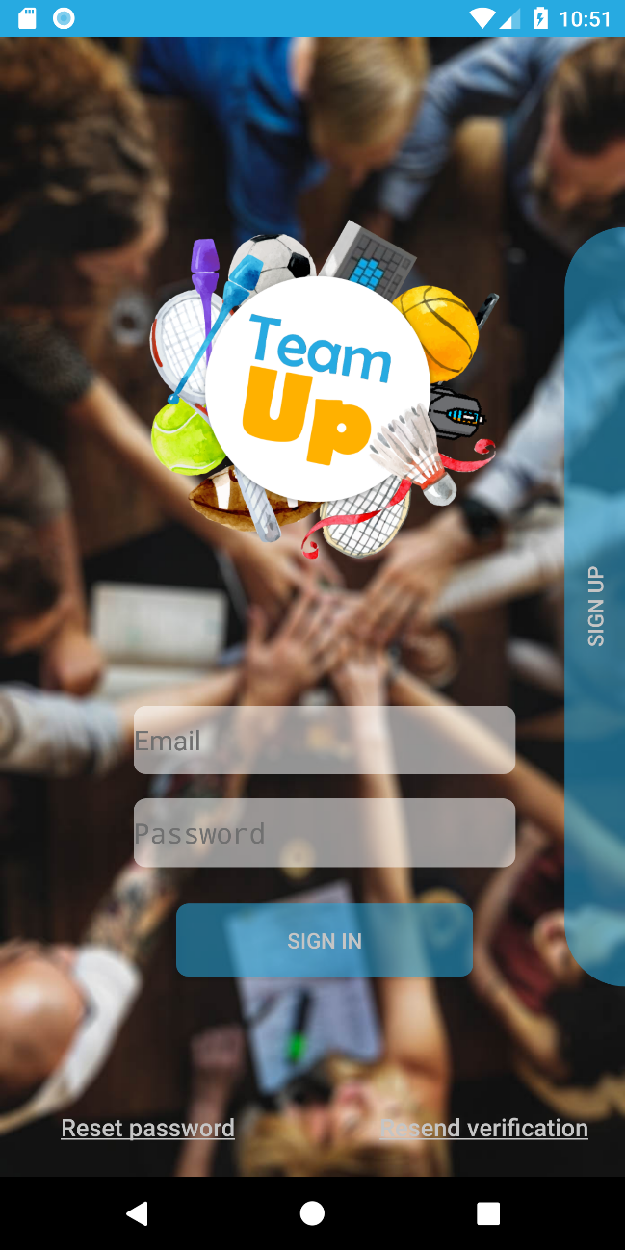

In order to Sign up you need to click the vertical **SIGN UP** button.

If after you have signed up you did not receive your verification email, click the R**esend verification** button in order to resend the verification email. If you still did not receive the email, you may want to check your spam.

In Log in you need to insert your email and password in the corresponding places.

In order to Log in you need to click the **SIGN IN** button with the email and password fields completed.

If you forgot your password, enter your email address and click the **Reset password** button in order to change it.

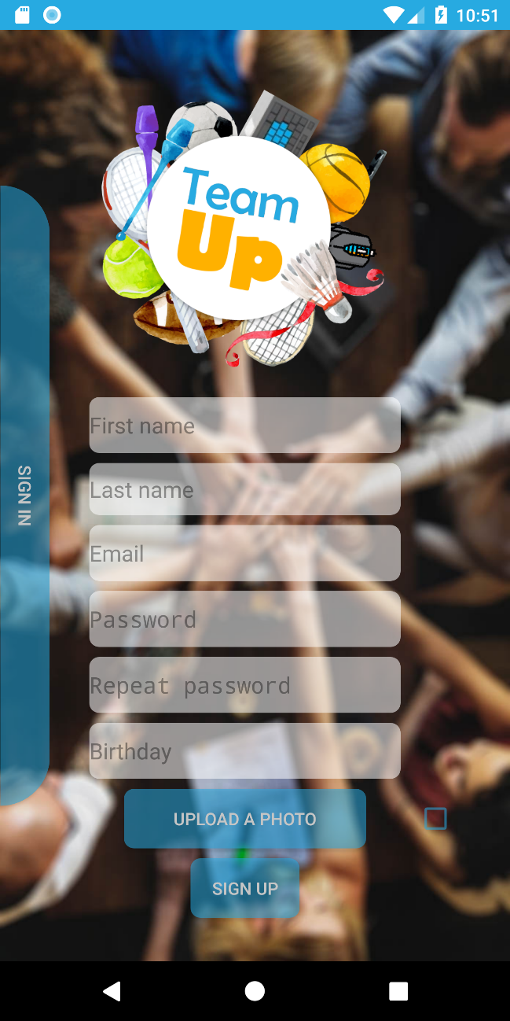

A profile photo is not mandatory but, if you choose to add one, a tick will appear if the operation was successful.

In order to sign up you need to fill in all the fields and press the **SIGN UP** button.

To go back to Log in, just press **SIGN** **IN**.

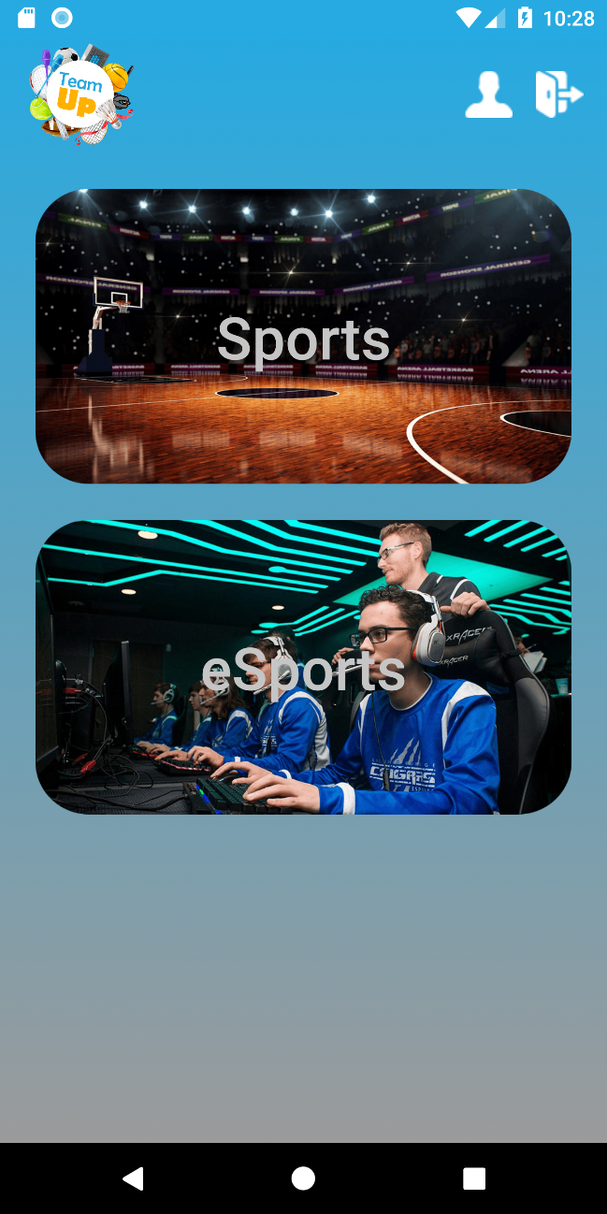

In order to sign out you need to press the **sign out icon**.

In order to see and edit your profile you need to press the **profile icon**.

In order to search a lobby, you need to choose between Sports and eSports, and press the appropriate button.

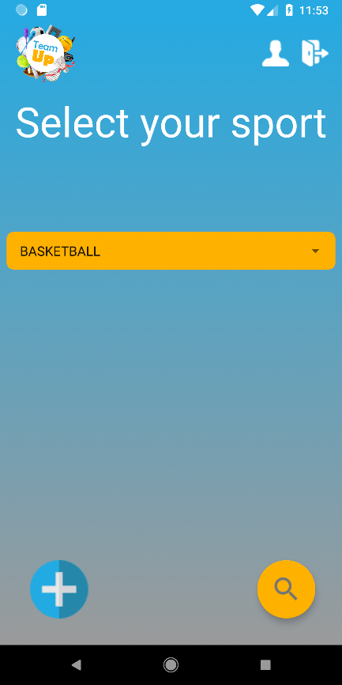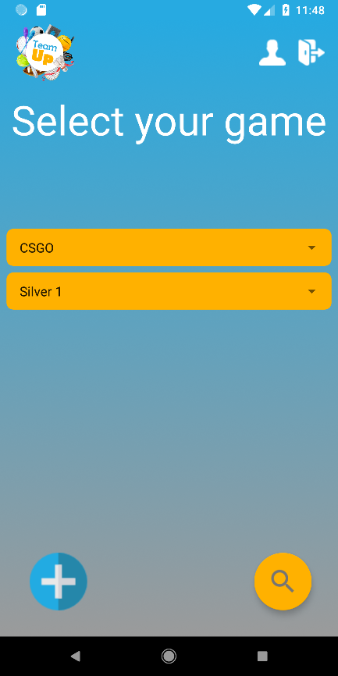

If you choose eSports, the window in the right image will appear. If you choose Sports, the window in the left image will appear. Tapping the **orange bar** will expand a list of Sports or eSports. For eSports, you can select your desired rank. Once you choose your desired sport/eSport, tap the **magnifier button** to search for lobbies.

If you want to create a lobby, tap the **„+” button.**

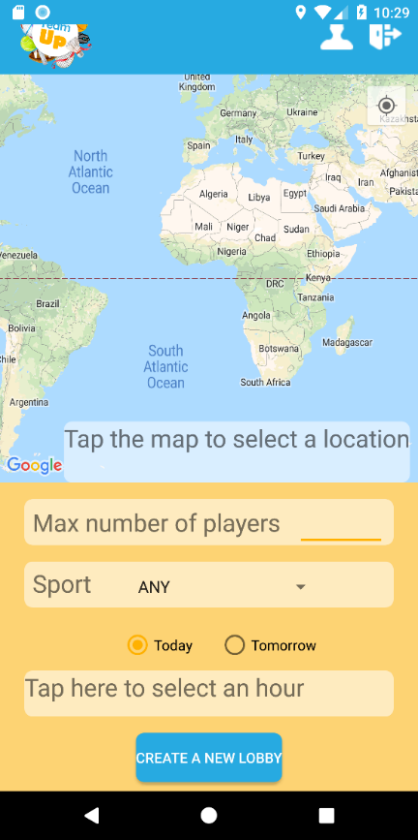 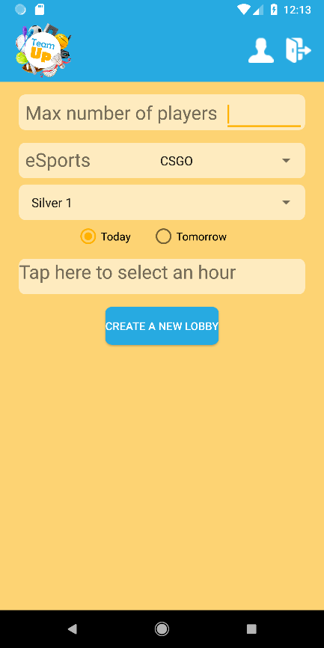

The right window is the one for creating a lobby for eSports, and the one on the left for creating a Sports lobby. Just fill in all the required information and press **„Create a new lobby”**

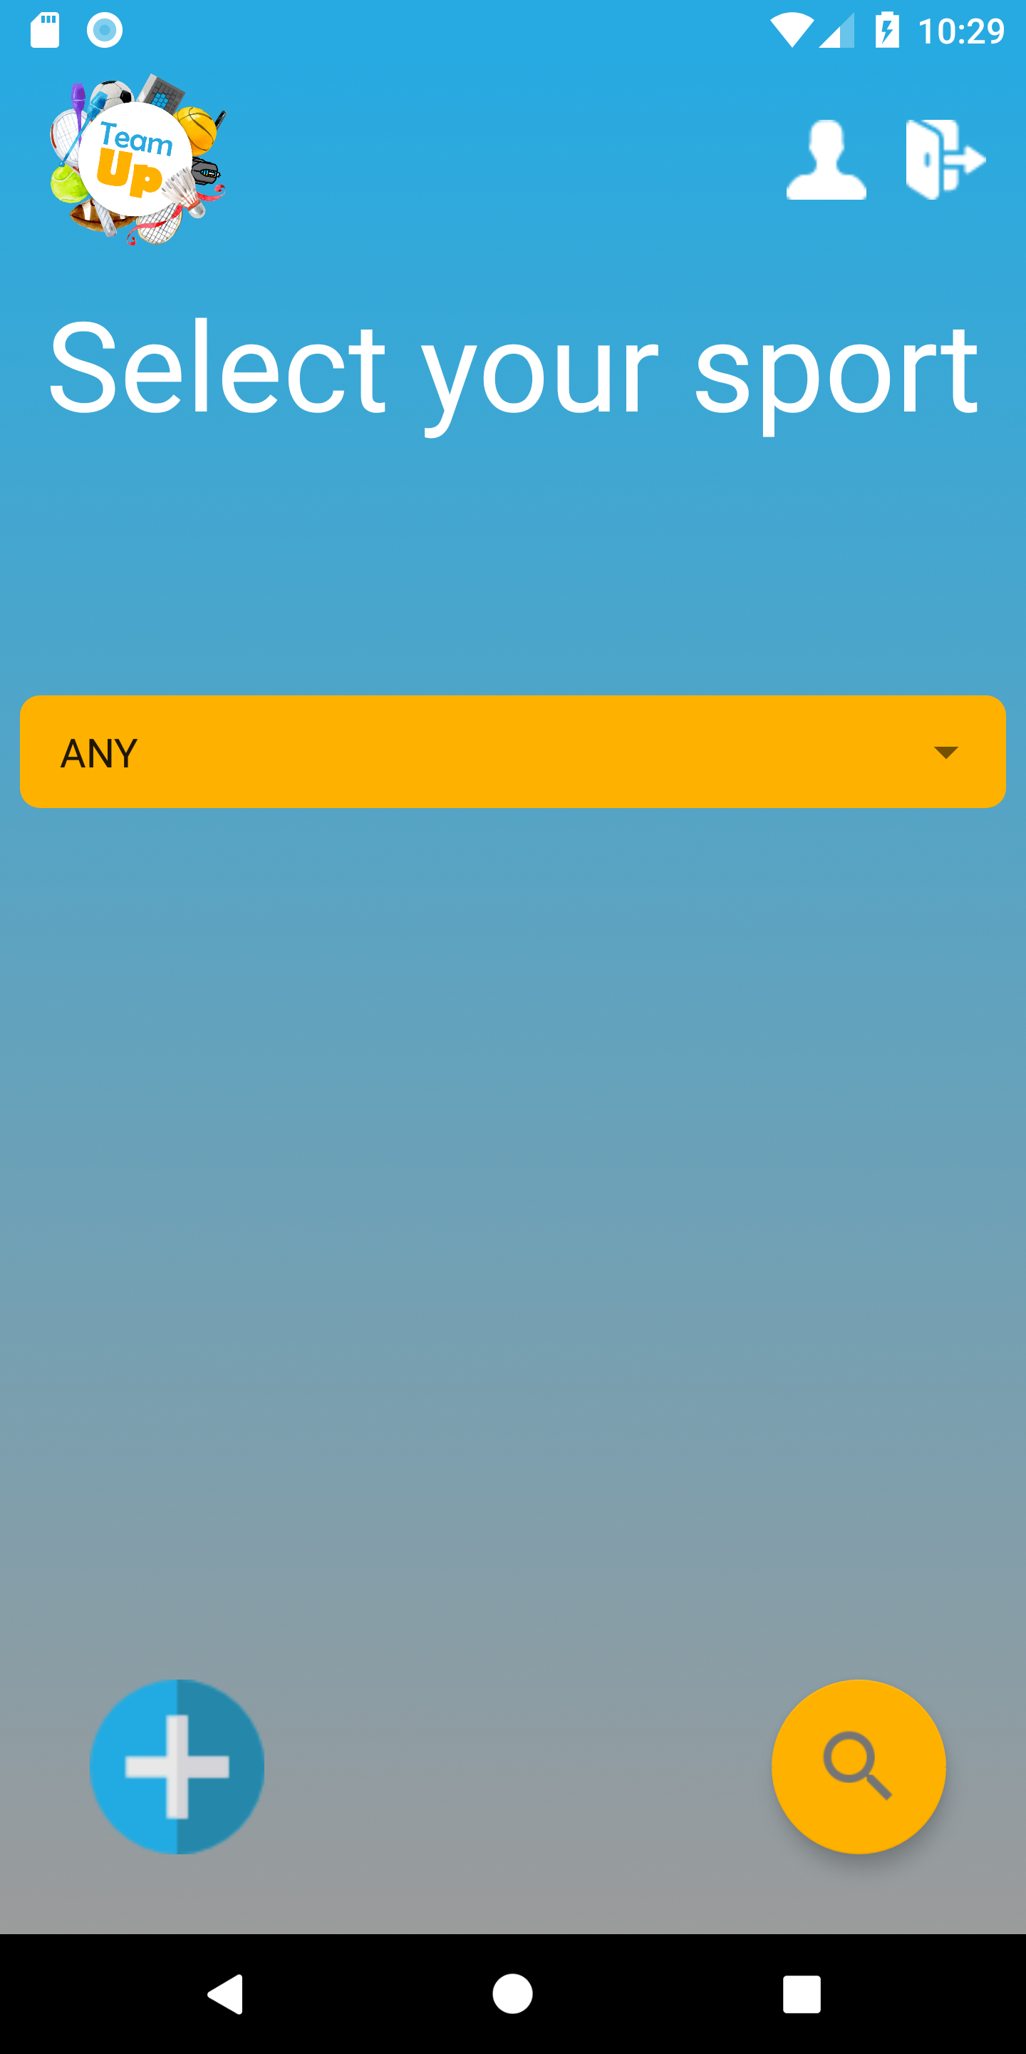

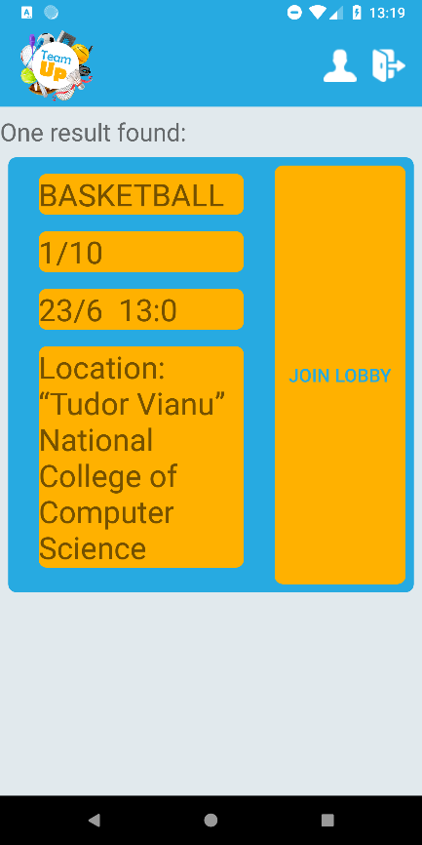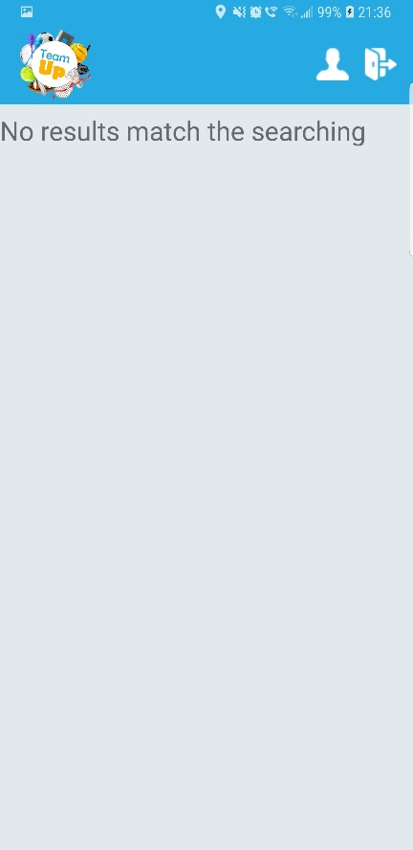  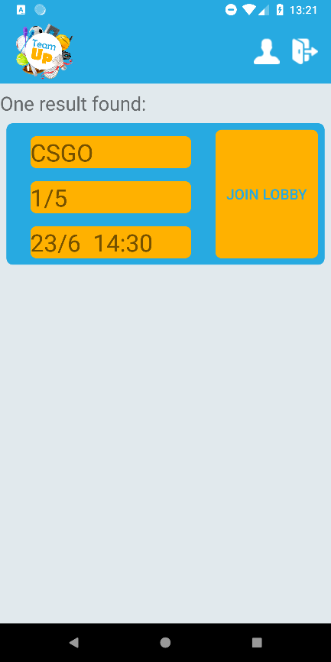

This is how the results appear. You can click **Join lobby** in order to join the lobby.

This is what appears when no lobbies are available.

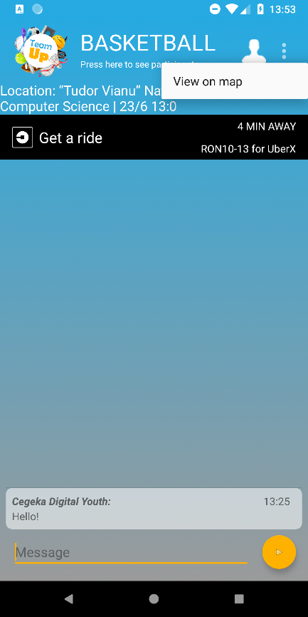 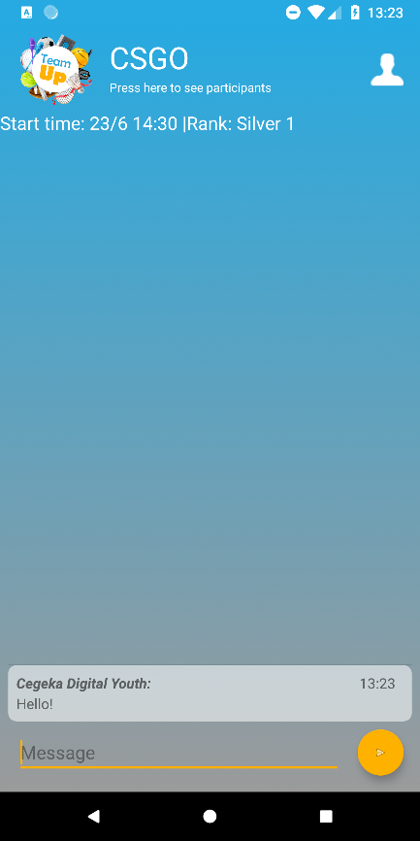

This is what the esports lobby looks like. It is similar to the sports lobby.

This is what a sports lobby looks like.

You can press the 3 dots and **View on map** in order to view the lobby location on a map. There is a chat where you can write messages.

The **Uber button** will redirect you to the Uber app.

You can press **Press here to see participants** for a list of lobby participants.

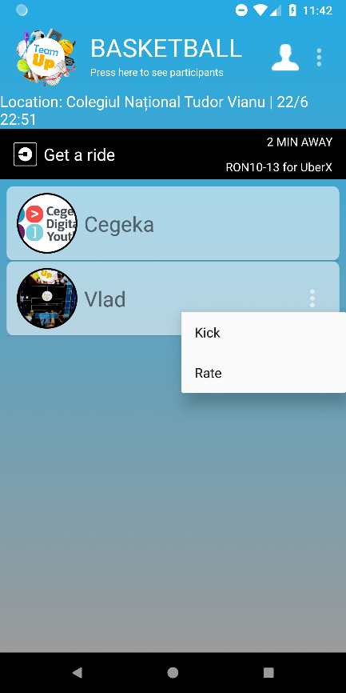 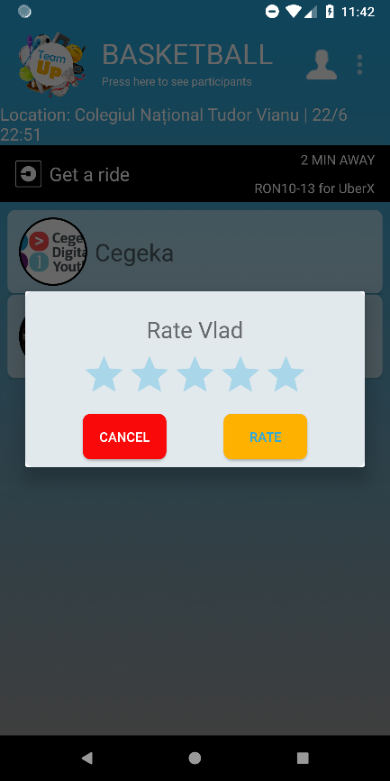

Everybody can rate the other players by selecting the number of stars and pressing **Rate**.

This is what the user list looks like. The lobby admin can kick and rate players. Tapping their name leads to their profile.

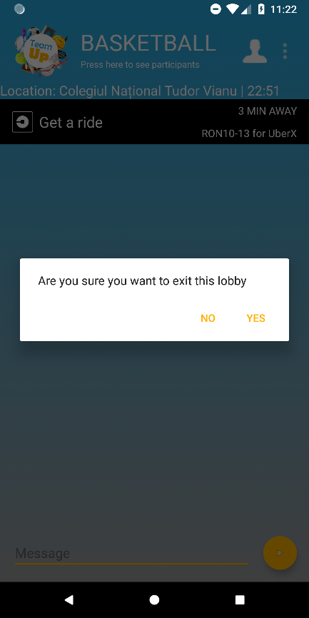

If you exit a lobby by pressing the back button a popup will appear asking you to confirm that you really want to exit.

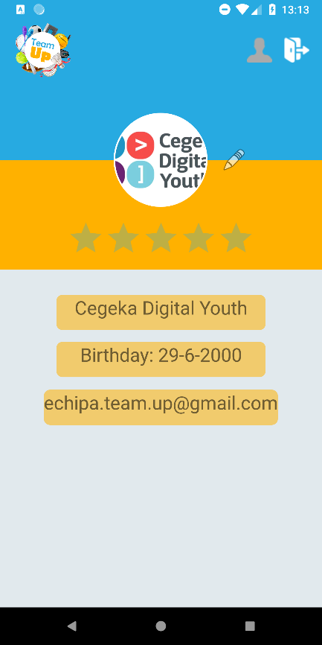

This is your **Profile**. By tapping the **Pencil icon**, you can change your profile image.

By tapping the profile image, a larger version will appear.